**ERD**

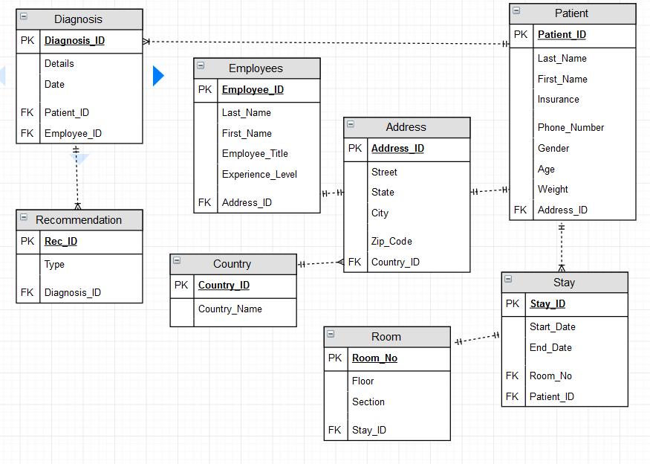

**SQL Reports**

**Aggregate function #1**

SELECT COUNT(STATE) AS "ADDRESSES IN COLORADO"

FROM ADDRESS

WHERE STATE = 'CO';

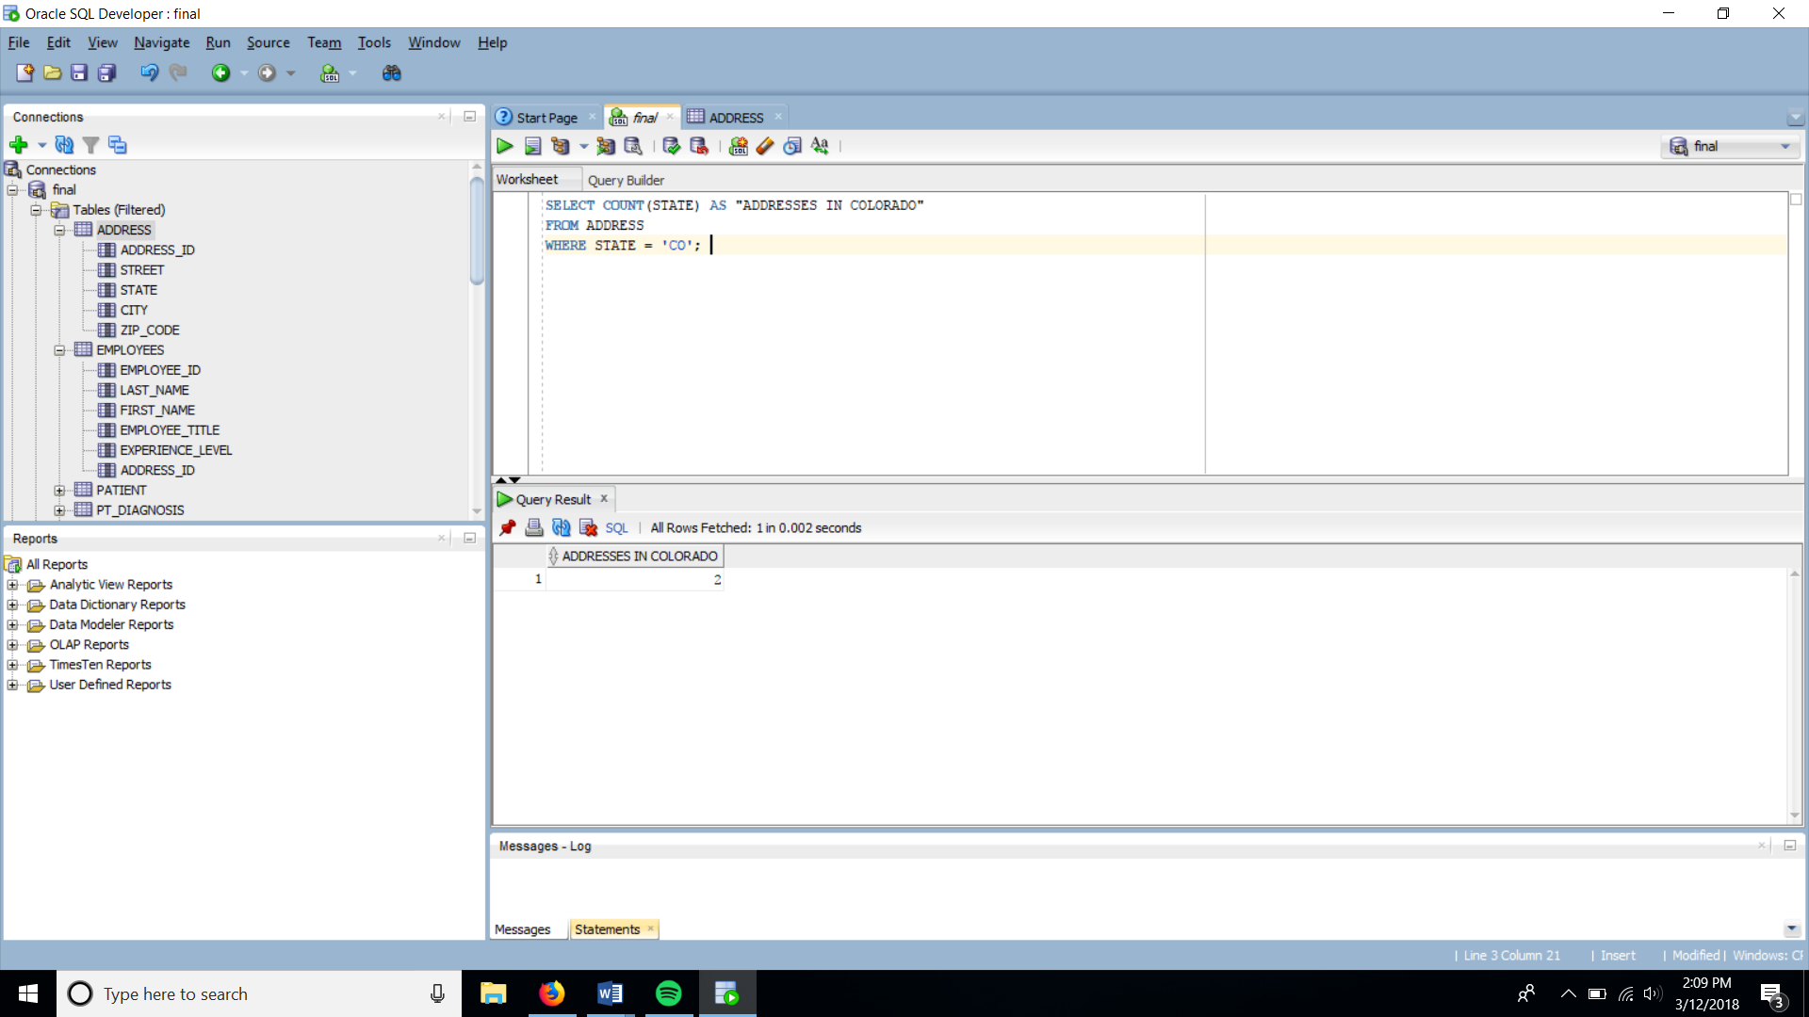

**Aggregate function #2**

SELECT COUNT(P.LAST_NAME)

FROM PATIENT P JOIN PT_DIAGNOSIS D

ON P.PATIENT_ID = D.PATIENT_ID

JOIN EMPLOYEES E ON D.EMPLOYEE_ID = E.EMPLOYEE_ID

JOIN STAY S ON P.PATIENT_ID = S.PATIENT_ID

WHERE E.EMPLOYEE_ID = 103 AND S.START_DATE > '01-FEB-18';

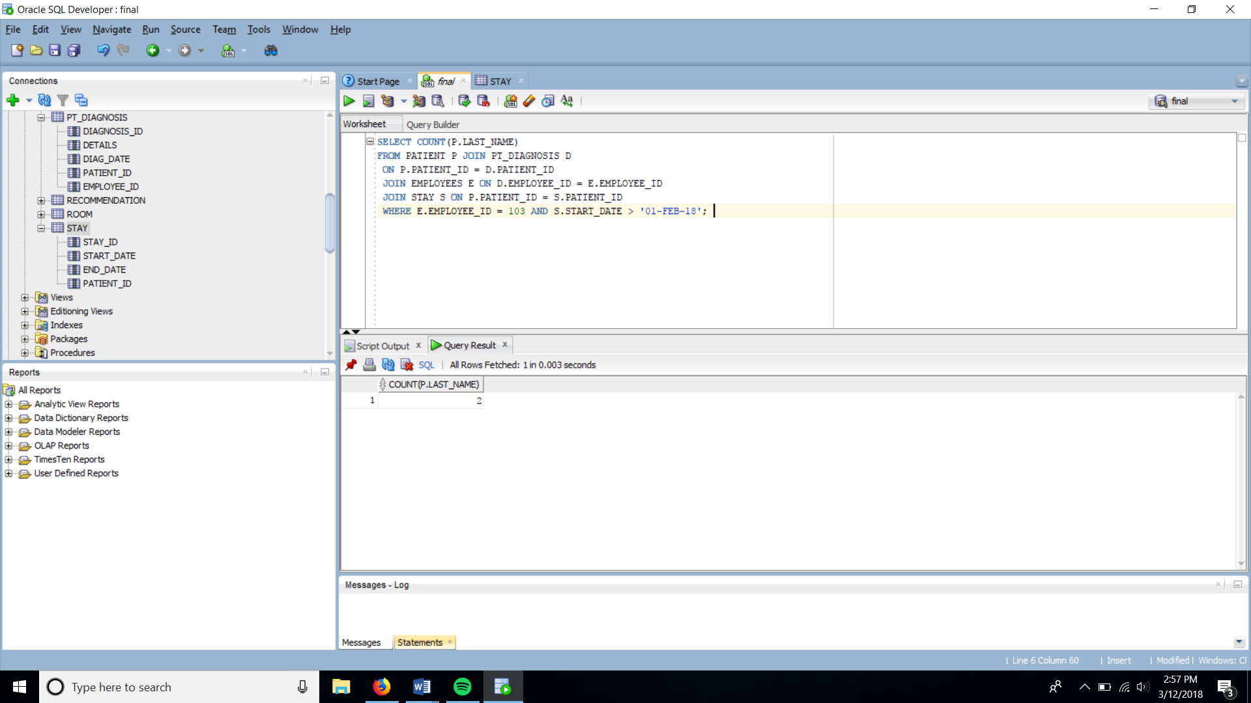

**Aggregate function #3**

SELECT MAX(START_DATE)

FROM STAY S JOIN PATIENT P ON S.PATIENT_ID = P.PATIENT_ID

WHERE GENDER = 'FEMALE';

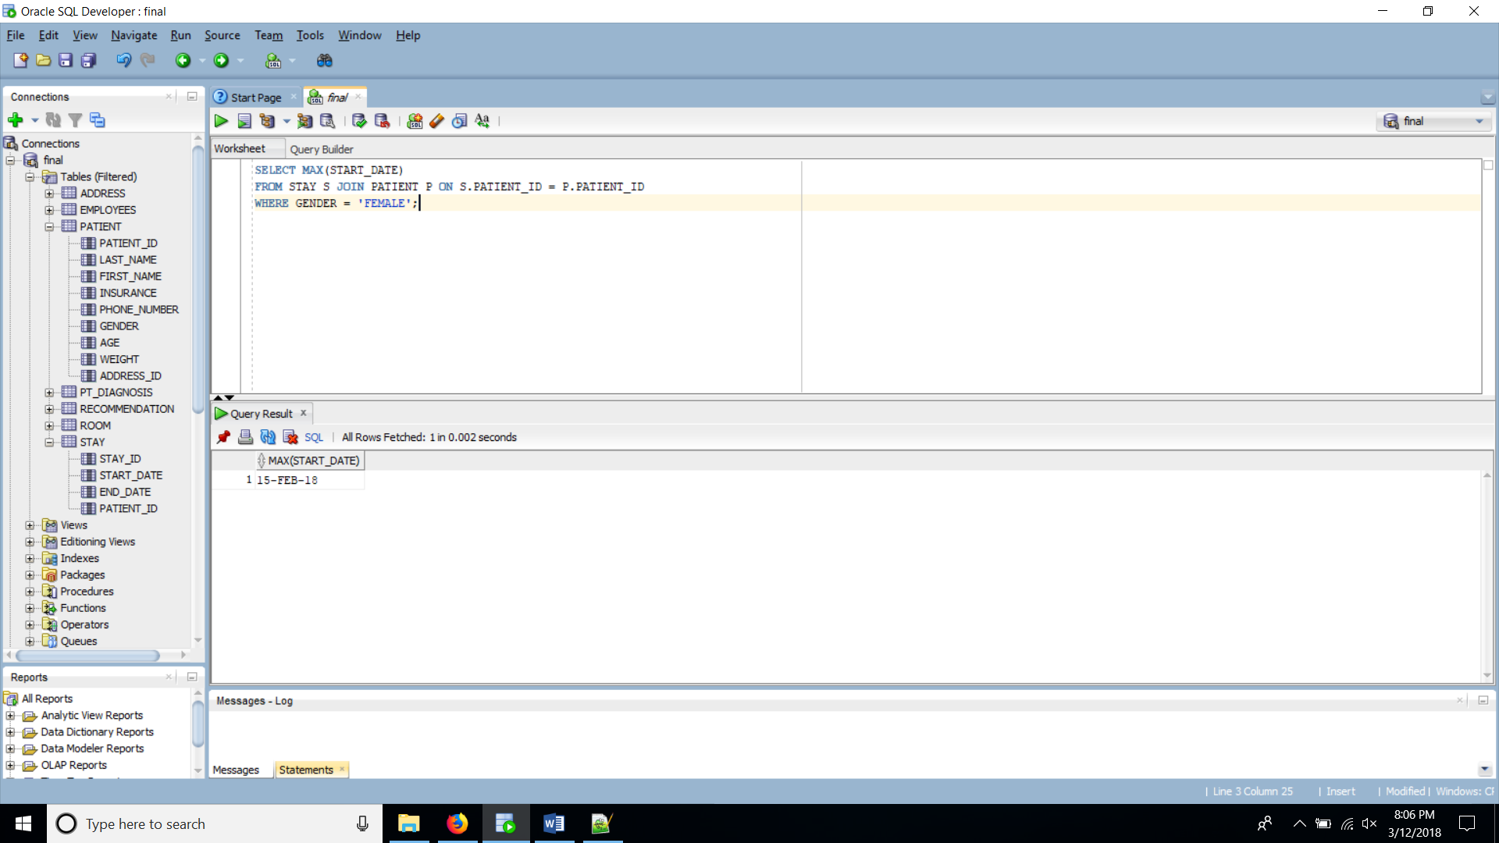

**Aggregate Function #4**

SELECT Min(START_DATE)

FROM STAY S JOIN PATIENT P ON S.PATIENT_ID = P.PATIENT_ID

WHERE GENDER = 'MALE';

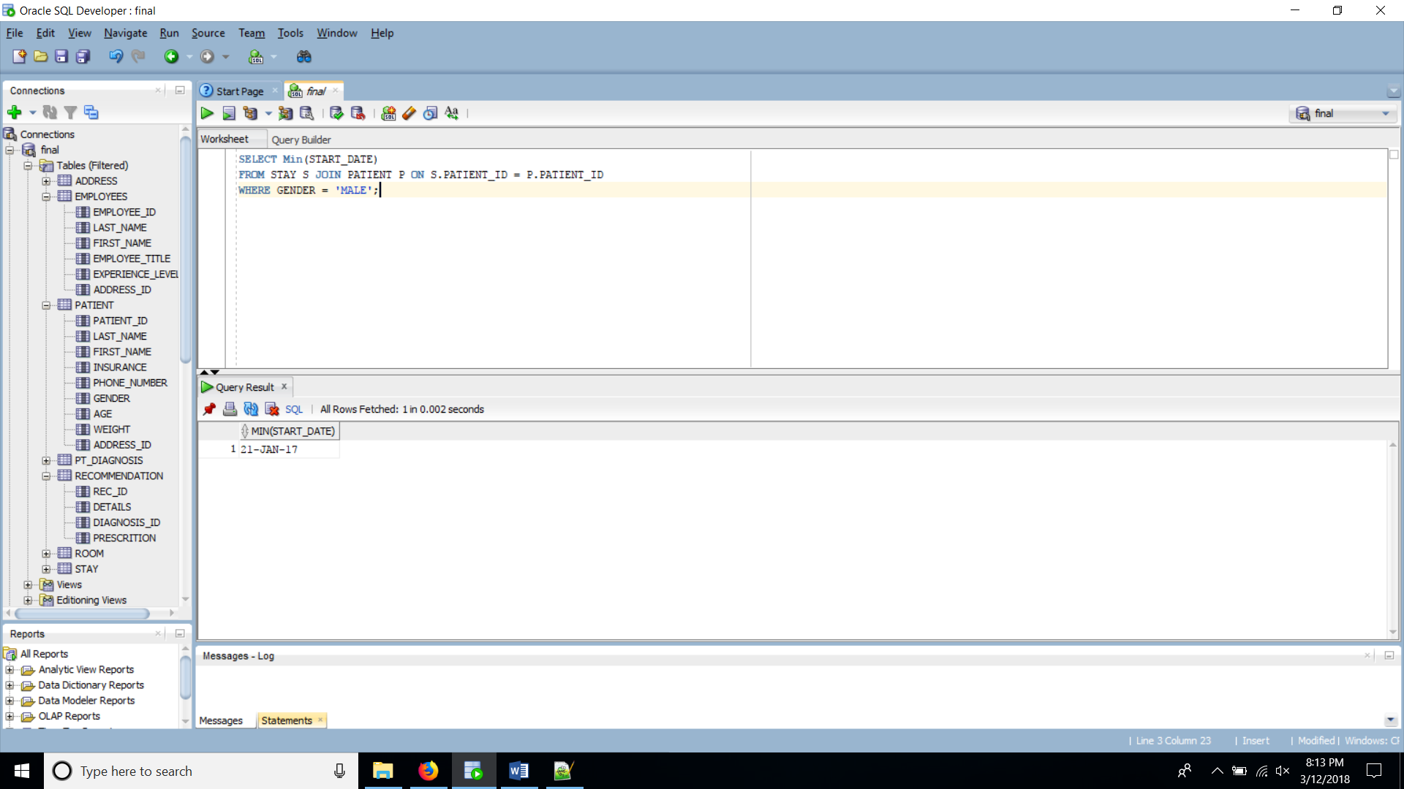

**Join #1**

SELECT P.PATIENT_ID, P.LAST_NAME, D.DETAILS AS "Diagnosis Details"

FROM PATIENT P JOIN PT_DIAGNOSIS D ON P.PATIENT_ID = D.PATIENT_ID;

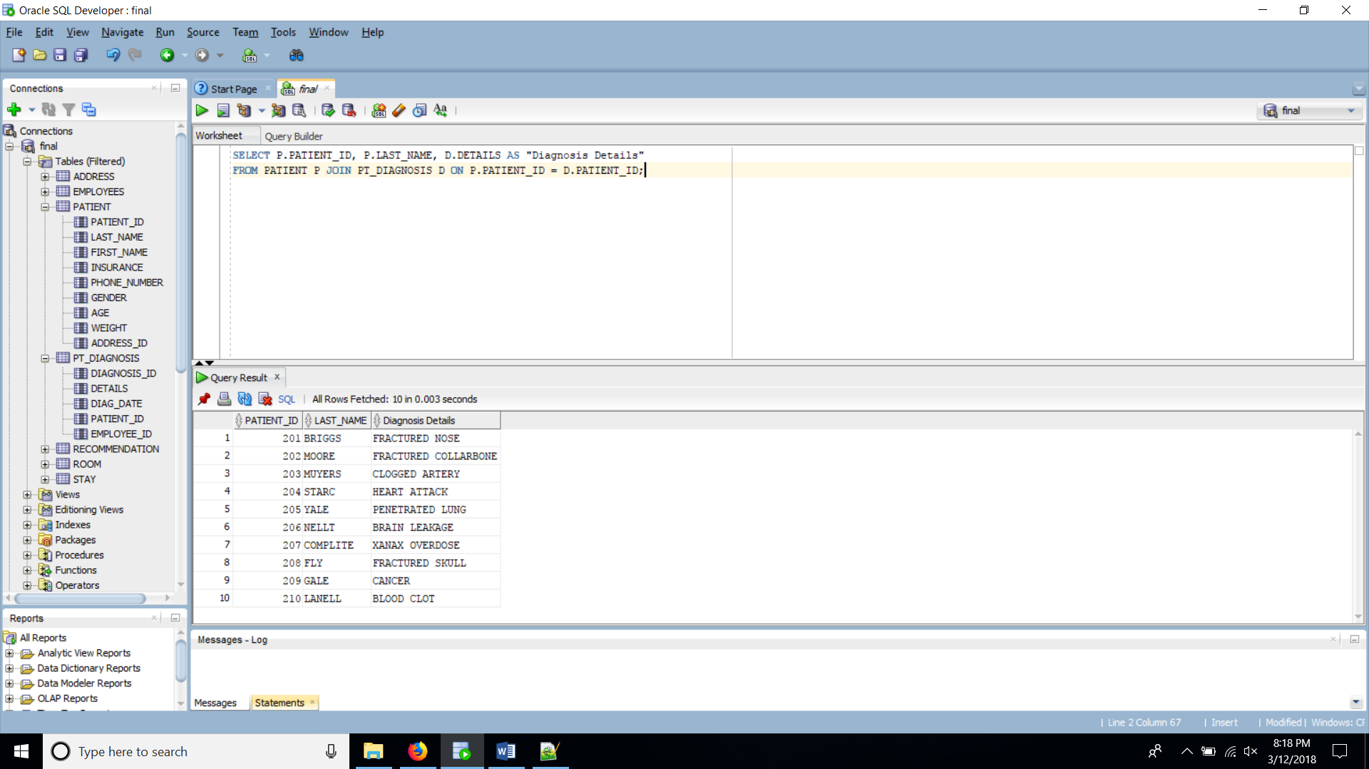

**Join #2**

SELECT P.PATIENT_ID, P.LAST_NAME, S.START_DATE, S.END_DATE

FROM PATIENT P JOIN STAY S ON P.PATIENT_ID = S.PATIENT_ID

WHERE LAST_NAME LIKE '%M%';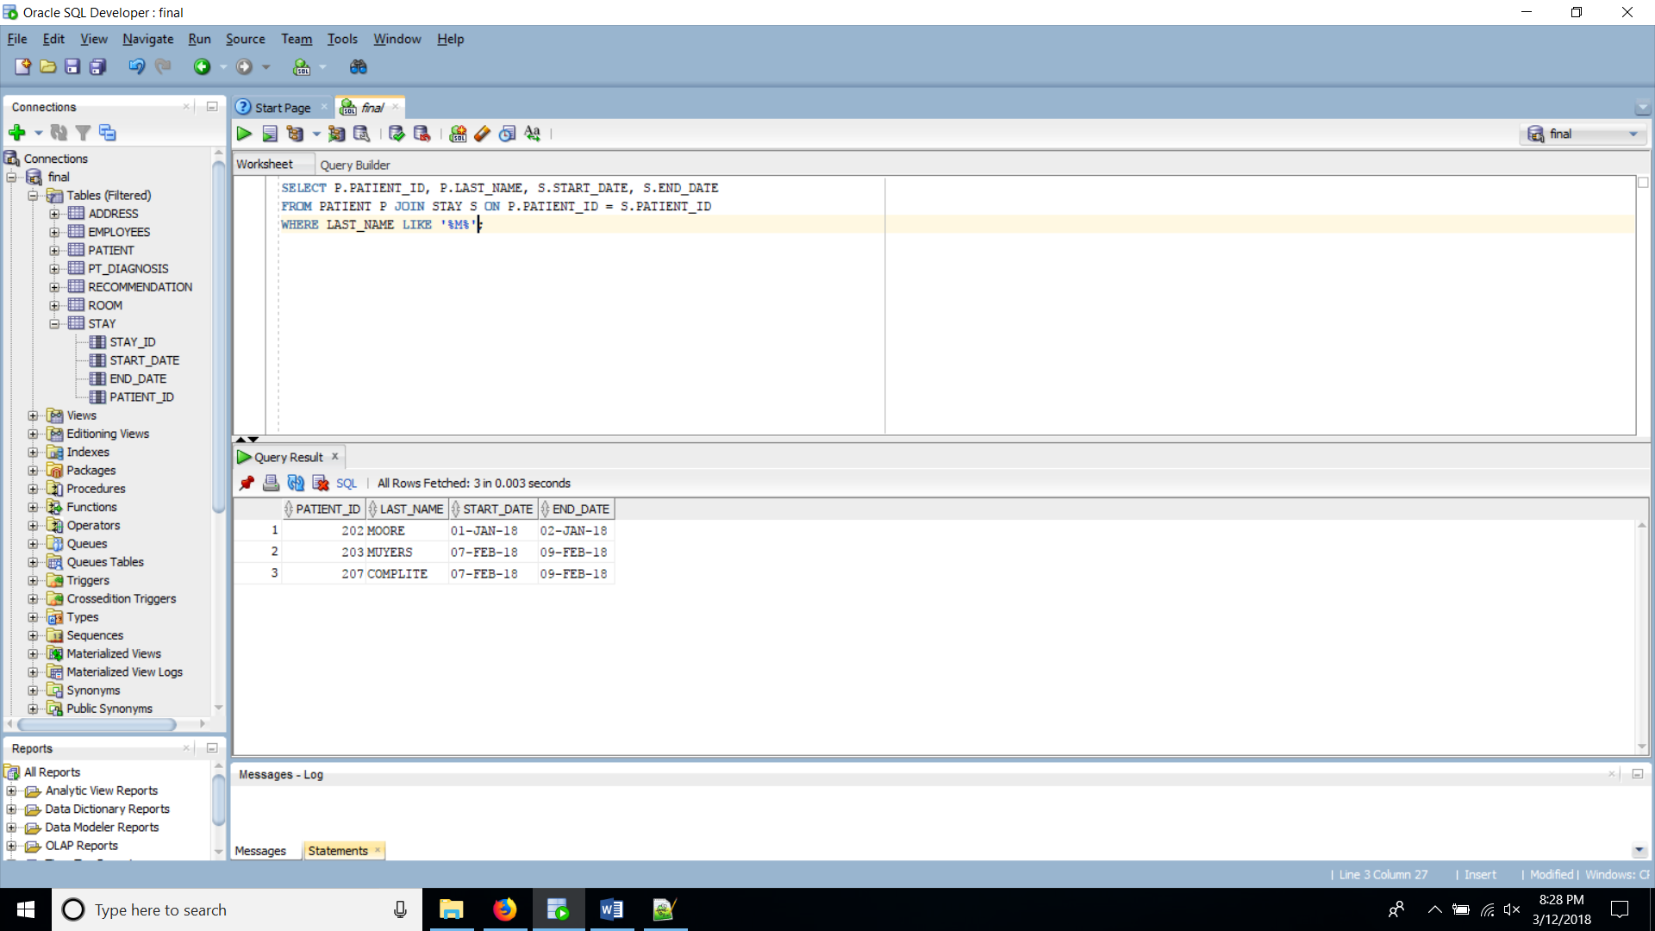

**Join with 3 tables #1**

SELECT P.PATIENT_ID, P.LAST_NAME, AD.CITY, D.DETAILS

FROM PATIENT P JOIN ADDRESS AD ON P.ADDRESS_ID = AD.ADDRESS_ID

JOIN PT_DIAGNOSIS D ON P.PATIENT_ID = D.PATIENT_ID

WHERE LAST_NAME LIKE '%F%';

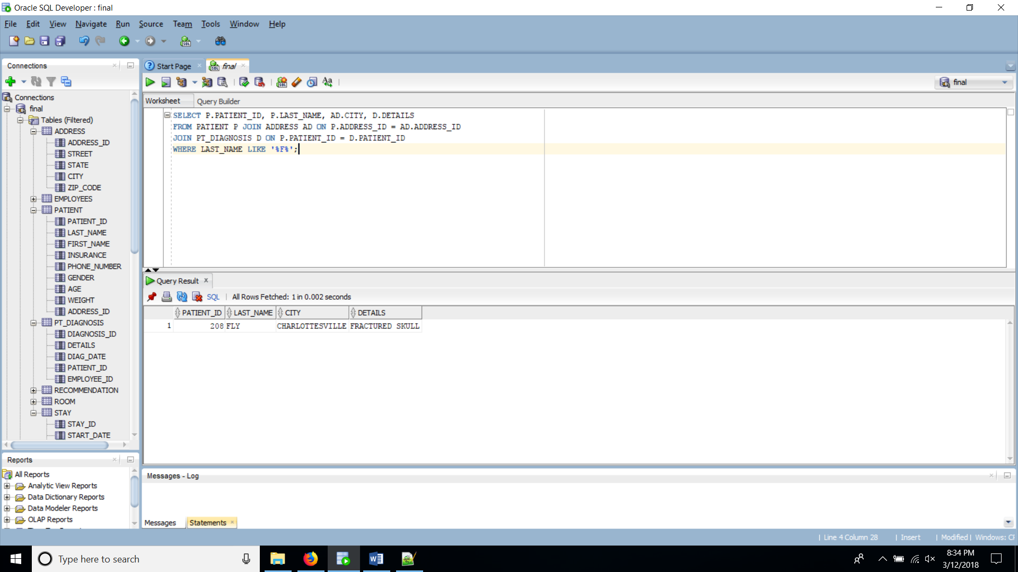

**Join with 3 tables #2**

SELECT P.LAST_NAME, R.ROOM_ID, R.FLOOR

FROM PATIENT P JOIN STAY S ON P.PATIENT_ID = S.PATIENT_ID

JOIN ROOM R ON S.STAY_ID = R.STAY_ID;

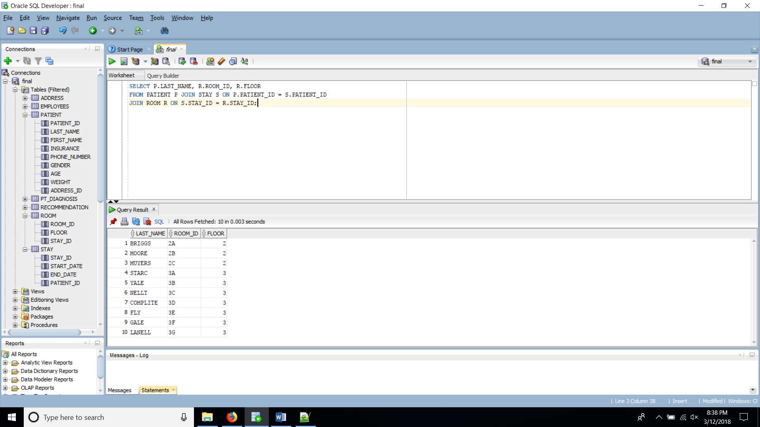

**Join with 3 tables #3**

SELECT LAST_NAME, A.CITY, C.COUNTRY_NAME

FROM EMPLOYEE E

JOIN ADDRESS A ON E.ADDRESS_ID = A.ADDRESS_ID

JOIN COUNTRY C ON A.COUNTRY_ID = C.COUNTRY_ID ;

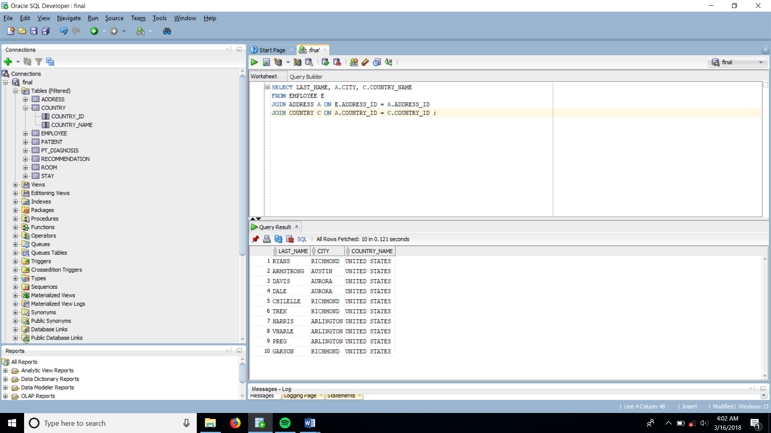

**Sub query (nested query)**

SELECT P.PATIENT_ID, P.LAST_NAME

FROM PATIENT P

WHERE PATIENT_ID IN

(SELECT PATIENT_ID

FROM PT_DIAGNOSIS

WHERE DIAGNOSIS_ID IN

(SELECT DIAGNOSIS_ID

FROM RECOMMENDATION

WHERE REC_ID = 555));

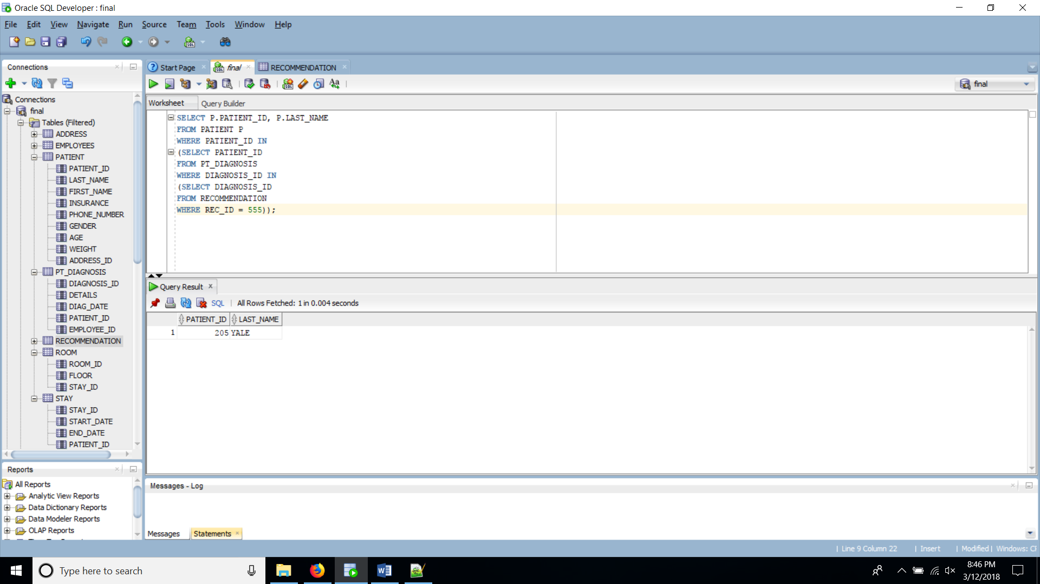

**Set operator #1**

SELECT LAST_NAME, ADDRESS_ID, EMPLOYEE_ID,00 AS "PATIENT_ID"

FROM EMPLOYEE

UNION

SELECT LAST_NAME, ADDRESS_ID, 00, PATIENT_ID

FROM PATIENT

ORDER BY ADDRESS_ID;

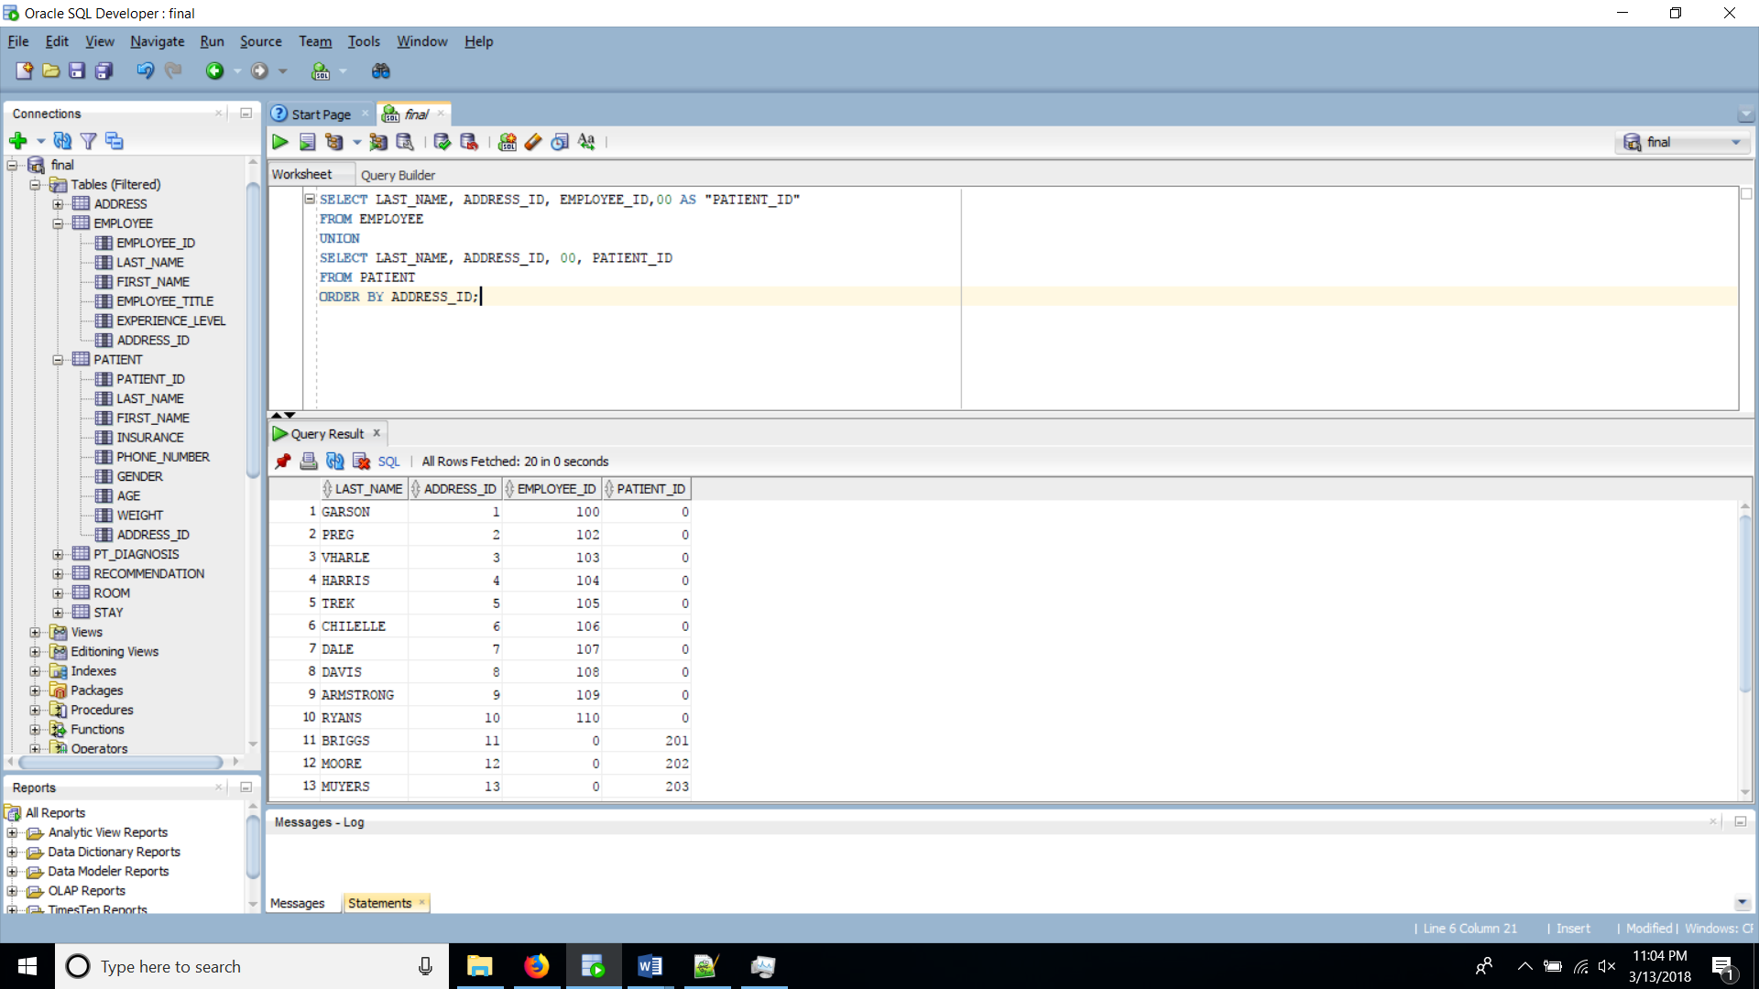

**Set operator #2**

SELECT DIAGNOSIS_ID, DETAILS

FROM PT_DIAGNOSIS

MINUS

SELECT DIAGNOSIS_ID, DETAILS

FROM RECOMMENDATION;

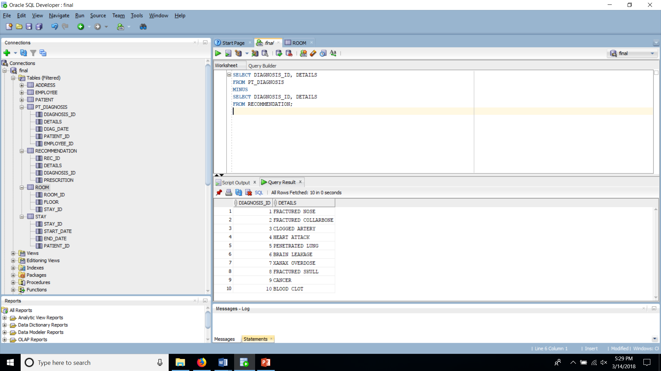

**INDEX Script- 1**

CREATE INDEX PT_DIAG_IDX

ON PT_DIAGNOSIS(DETAILS);

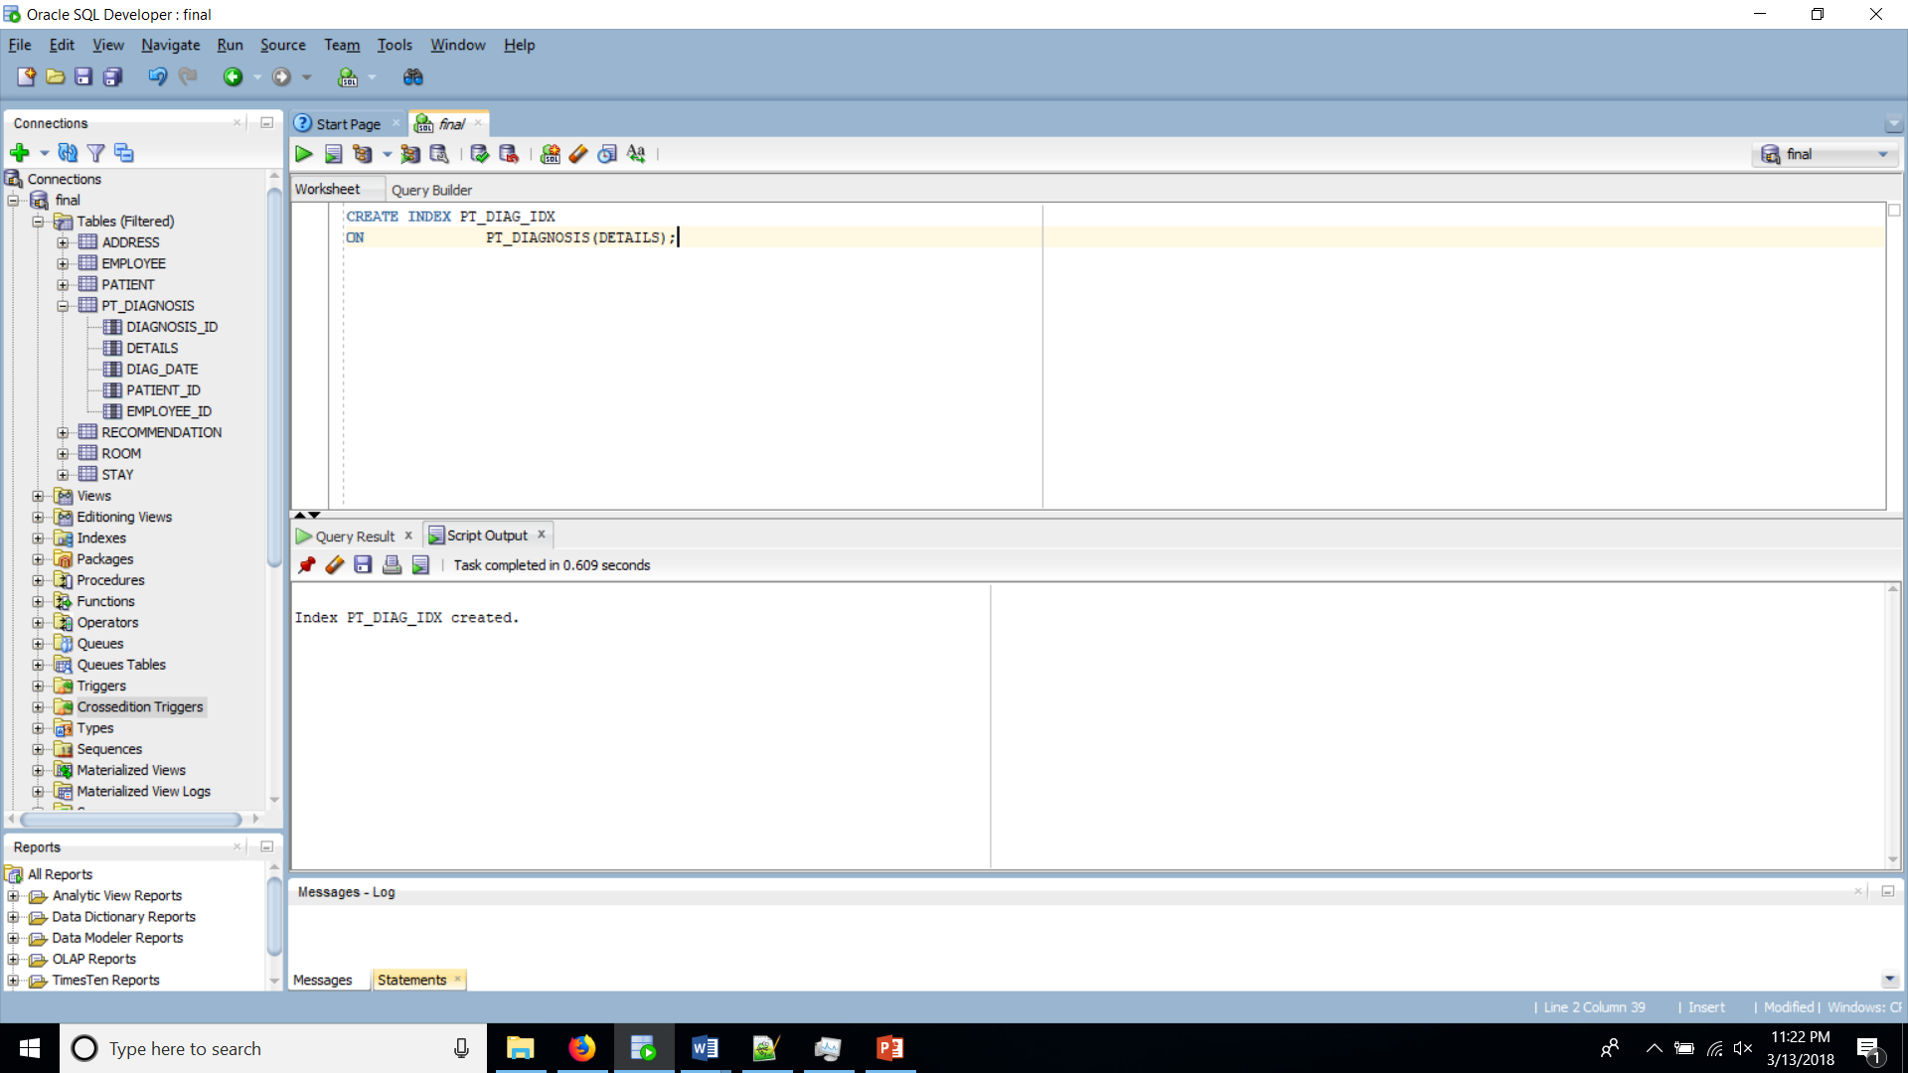

**INDEX Script- 2**

CREATE INDEX LS_NM_IDX

ON PATIENT(LAST_NAME);

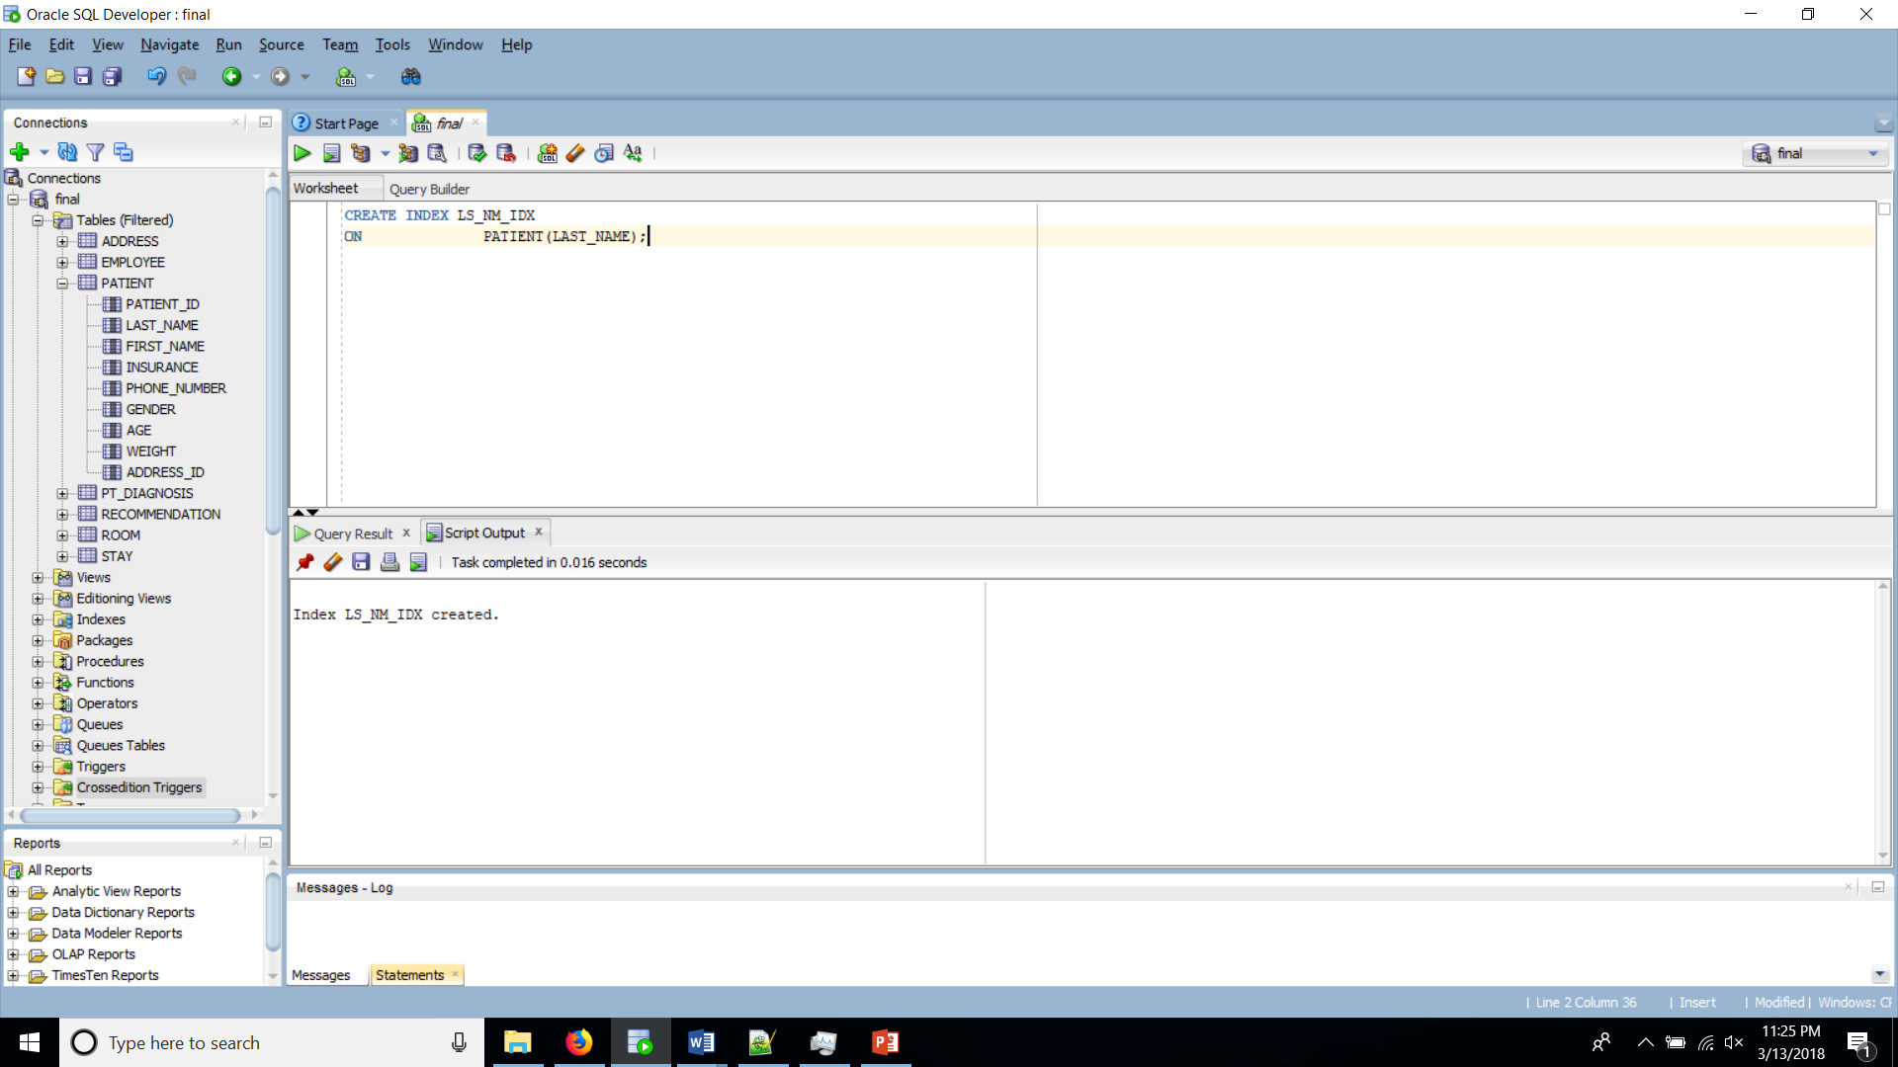

**INDEX Script- 3**

CREATE INDEX EMP_LN_IDX

ON EMPLOYEE(LAST_NAME);

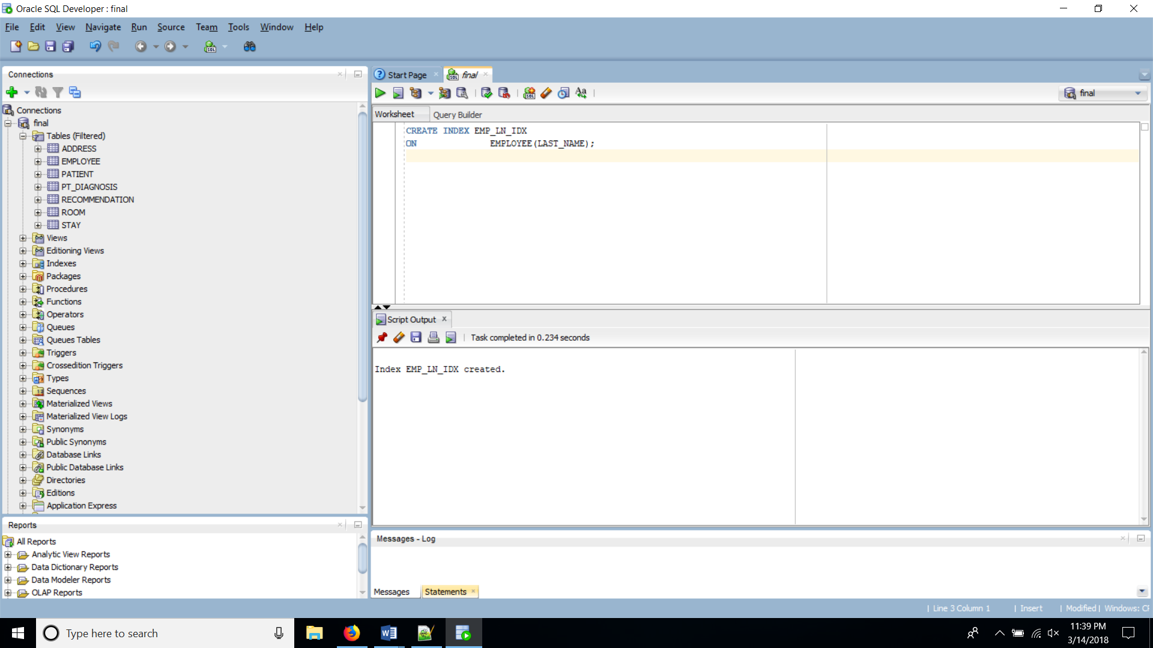

**View 1-**

CREATE VIEW PATEMPVU1

AS SELECT P.LAST_NAME, P.AGE, D.DIAG_DATE FROM PATIENT P

JOIN PT_DIAGNOSIS D ON P.PATIENT_ID = D.PATIENT_ID

WHERE P.PATIENT_ID > 205

WITH CHECK OPTION CONSTRAINT PATEMPVU1_CK

;

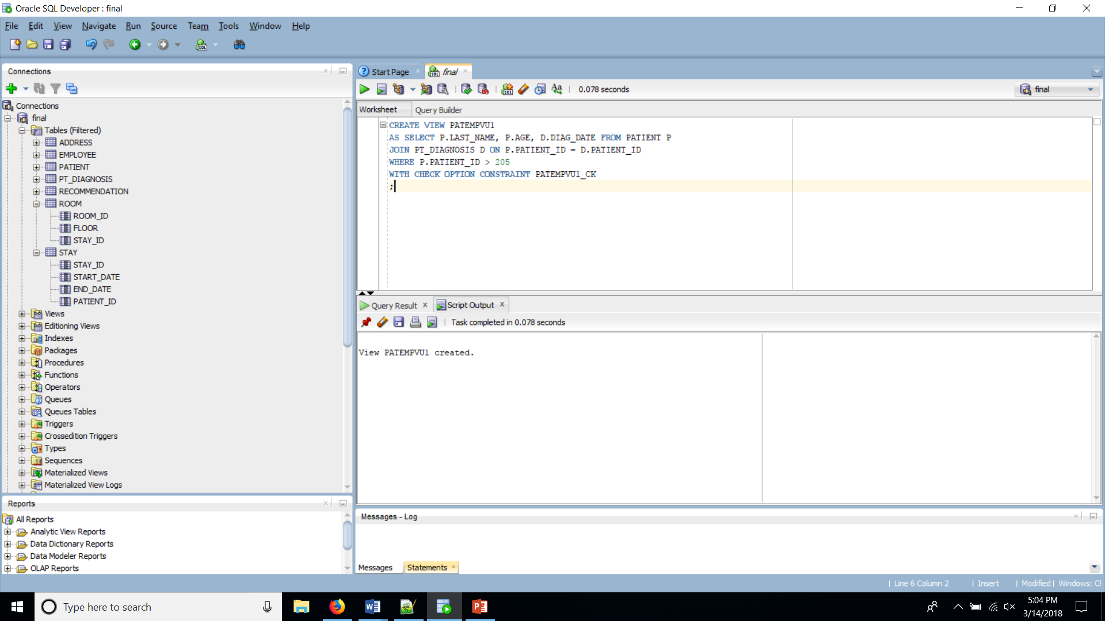

**View 2-**

CREATE VIEW roomst2

AS SELECT P.LAST_NAME, R.ROOM_ID, S.START_DATE

FROM PATIENT P JOIN STAY S ON P.PATIENT_ID = S.PATIENT_ID

JOIN ROOM R ON S.STAY_ID = R.STAY_ID

WITH CHECK OPTION CONSTRAINT ROOMST2_CK;

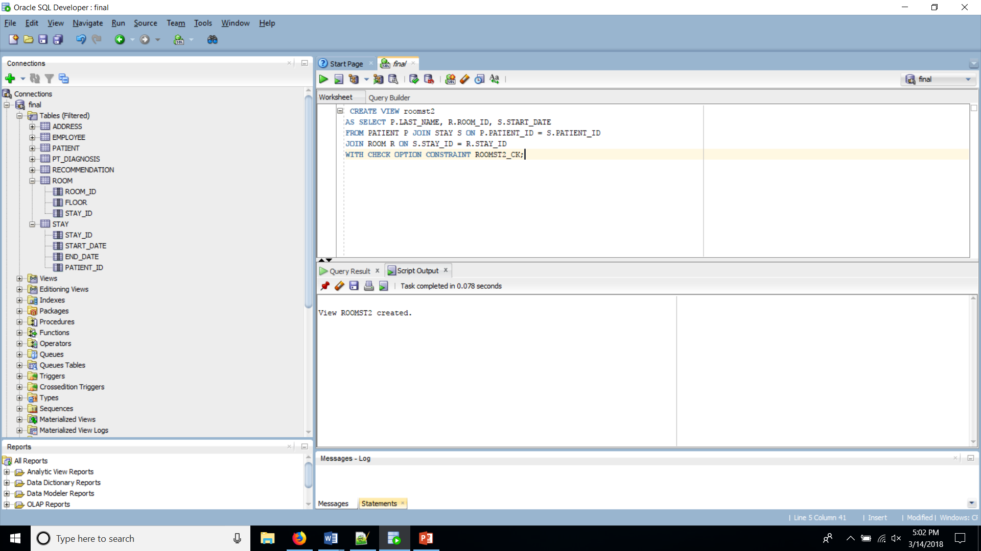

**Sequence-**

CREATE SEQUENCE PAT_ID_SEQ

INCREMENT BY 1

START WITH 200

MAXVALUE 210

NOCACHE

NOCYCLE;

